The Teach Hub 2-week units of work

Year N/ R Whole Class Reading Units – The Teach Hub

YrN/R Whole Class Reading Owl Babies by Martin Waddell
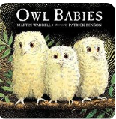
A text to show the relationship between three baby owls who miss their mummy
and their feelings.

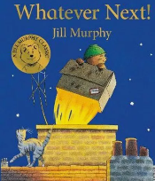
YrN/R Whole Class Reading Whatever Next by Jill Murphy
Join Baby Bear as he finds a rocket, makes friends with an owl and
has a picnic on the moon!

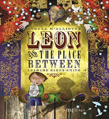
YrR Whole Class Reading Leon and the Place Between by Grahame Baker-Smith
Wanting to prove to his brothers and sister that magic really exists, Leon volunteers
to be in Abdul Kazam's magic show and gets transported to a mysterious world.

YrR Whole Class Reading Dear Zoo by Rod Campbell
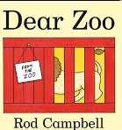
A child writes to the zoo for a pet and the zoo sends a number of unsuitable pets,
revealed behind flaps in the form of crates and packing cases.

YrR Whole Class Reading Alan’s Scary Teeth by Jarvis
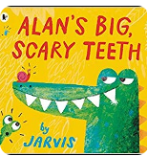
Alan the crocodile owns some big scary teeth, but what happens when he
loses them?

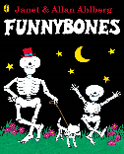
YrR Whole Class Reading Funnybones by Alan Ahlberg
These funny skeletons are definitely not the scary sort!

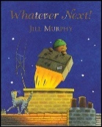
YrR Whole Class Reading Whatever Next
Join Baby Bear as he finds a rocket, makes friends with an owl and has a picnic
on the moon!

YrR Whole Class Reading Handa’s Surprise
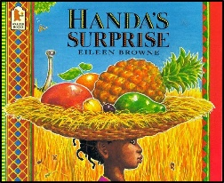
Richly illustrated, brimming with luscious fruit and cheeky wild animals, this
mouth-watering story is for the youngest of readers.

Year 1 Whole Class Reading Units - The Teach Hub

Yr1 Whole Class Reading Leon and the Place Between by Grahame Baker-Smith
Wanting to prove to his brothers and sister that magic really exists, Leon volunteers
to be in Abdul Kazam's magic show and gets transported to a mysterious world.

Yr1 Whole Class Reading Owl Babies by Martin Waddell
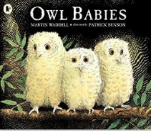
A text to show the relationship between three baby owls who miss their mummy
and their feelings - good for early Year 1 work.

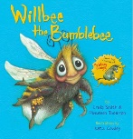
Yr1 Whole Class Reading Willbee the Bumblebee by Maureen Thomson and
Craig Smith
Willbee has a problem with his clothing and others help him to sort it out.

Yr 1 Whole Class Reading Farmer Duck by Martin Waddell
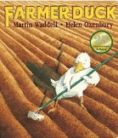
Poor Farmer Duck must do all the work around the house - will the farmer
ever get out of bed?

Yr1 Whole Class Reading Some Dogs Do by Jez Alborough
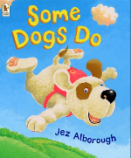
On the way to school one day, Sid is so full of happiness that he starts to fly. But
no one believes him. Dogs don't fly, they say. Poor Sid is miserable, until his dad
lets him in on an amazing secret: some dogs do!

Yr1 Whole Class Reading The Very Hungry Caterpillar by Eric Carle
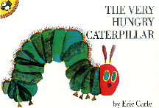
Follow the progress of a very hungry caterpillar as he eats his way through
the week.

Yr1 Whole Class Reading Funnybones by Allan Ahlberg
These funny skeletons are definitely not the scary sort!

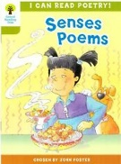
Yr1 Whole Class Reading Poetry - I Like...by Moira Andrew
Use your senses to explore what you like and what you do not like in this
fun poem.

Yr1 Whole Class Reading Open Very Carefully. A Book with Bite! by Nick Bromley
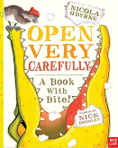
This very grumpy crocodile has ended up in totally the wrong book, so he proceeds
to eat his way out!

Yr1 Whole Class Reading Little Red Riding Hood retold by Bev Evans
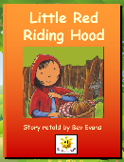
This traditional tale of Little Red Riding Hood visiting her grandmother retold in a
simple and colourful way.

Yr1 Whole Class Reading The Three Little Pigs retold by Bev Evans
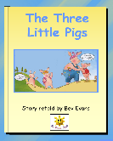
This traditional tale of the three little pigs and the wolf, retold in a simple and
colourful way.

Yr1 Whole Class Reading The Elephant and the Bad Baby by Elfrida Vipont
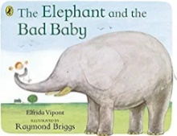
The Elephant takes the Bad Baby for a ride and they go 'rumpeta, rumpeta,
rumpeta down the road.' All ends well as the baby learns to say, ‘Please’.

Yr1 Whole Class Reading Bonfire Night Poetry by Irene Yates
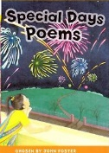
Visualise the beautifully lit night sky with your Year One children using
this descriptive poem.

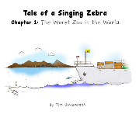
Yr1 Whole Class Reading Roy the Singing Zebra by Tim Bowerbank (online)
Roy lives in a zoo and he is not allowed to sing.

Yr1 Whole Class Reading Alan’s Big, Scary Teeth by Jarvis
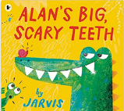
Alan the crocodile owns some big scary teeth, but what happens when he loses them?

Yr1 Whole Class Reading Super Daisy by Kes Gray and Nick Sharratt
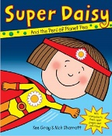
Peas with pizza, peas with ice cream and even peas with lemonade! A job for Super
Daisy!

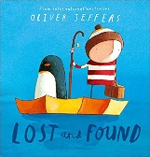
Yr1 Whole Class Reading Lost and Found by Oliver Jeffers
A boy finds a penguin on his doorstep. The boy decides the penguin must be lost
and tries to return him.

Yr1 Whole Class Reading The Tiger That Came to Tea
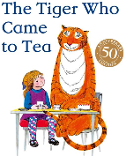
The doorbell rings just as Sophie and her mummy are sitting down to tea. Who
could it possibly be? What they certainly don't expect to see at the door is a big furry,
stripy tiger!

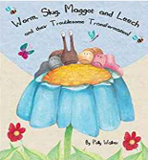
Yr1 Whole Class Reading Worm, Slug, Maggot and Leech by Polly Walker
The story of four creatures who are unhappy with their looks, so they decide to
try and change.

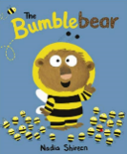
Yr1 Whole Class Reading Bumblebear by Nadia Shireen
A delightful story about a bear that wanted to go to Bumblebee school to get some
honey.

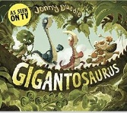
Yr1 Whole Class Reading Gigantosaurus by Jonny Duddle
A dinosaur book with a funny ending!

Yr1 Whole Class Reading The Lion Inside by Rachel Bright
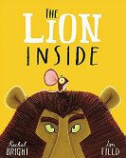
You don’t have to be big and brave to find your roar.

Yr1 Whole Class Reading Tom and the Island of Dinosaurs by Ian Beck
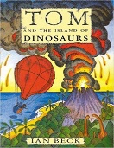
The last of the dinosaurs are saved in a daring rescue in this exciting adventure book.

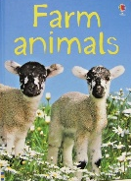
Yr1 Whole Class Reading Farm Animals by Katie Dayne
A non-fiction unit based on farm animals - perfect for Year 1.

Yr1 Whole Class Reading Jack and the Beanstalk retold by Bev Evans
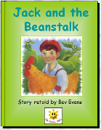
This traditional tale of the three little pigs and the wolf, retold in a simple and
colourful way.

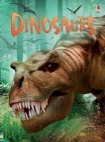
Yr1 Whole Class Reading Dinosaur by Stephanie Turnbull
This non-fiction unit will bring dinosaurs to life!

Yr1 Whole Class Reading Dinosaurs in my School by Timothy Knapman and
Sarah Warburton
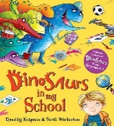
For one little boy school is turned upside down when the dinosaurs arrive.

Yr1 Whole Class Reading Dogger by Shirley Hughes
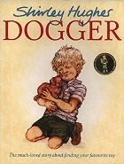
A firm favourite for Year One children. Dave loses his favourite toy, Dogger, and
he is desolate, but then Dogger turns up at the school summer fair.

Yr1 Whole Class Reading The Very Busy Spider by Eric Carle
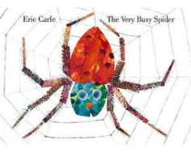
Early one morning a little spider spins her web on a fence post. One by one, the
animals of the nearby farm try to distract her, yet the busy little spider keeps
diligently at her work.

Yr1 Whole Class Reading The Lonely Christmas Tree by Chris Naylor-Ballesteros
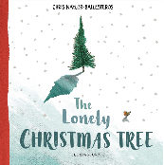
A beautiful Christmas poem with an uplifting message of love and celebrating being
together.

Yr 1 Whole Class Reading A Squash and a Squeeze by Julia Donaldson
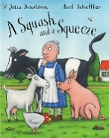
Discover how an old lady tries to solve the problem of living in a small farmhouse
in this funny rhyming story.

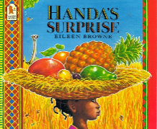
Yr 1 Whole Class Reading Handa’s Surprise by Eileen Browne
Handa decides to take seven pieces of delicious fruit to her friend, Akeyo, who lives
in the neighbouring village, but they disappear on the way!

Yr 1 Whole Class Reading Silly Billy by Anthony Browne
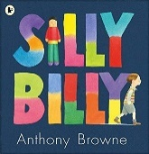
Billy is a bit of a worrier but when he stays with his Grandma, she helps him by giving
him some worry dolls.

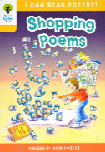
Yr 1 Whole Class Reading Shopping List Poetry by Julie Holder
Take a shopping trip with your Year 1 class to buy everything you need with this
rhythmical poem.

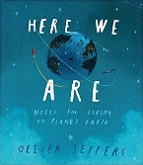
Yr 1 Whole Class Reading Here We Are by Oliver Jeffers
Discover the delights of the planet Earth with this thought-provoking picture book.

KS1 Whole Class Reading The Fairy Who Sings by Cheryl Davies
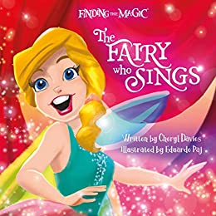
A beautifully illustrated rhyming story, which encompasses the magic of fairies
with important key messages of self-esteem, friendship, kindness and courage.

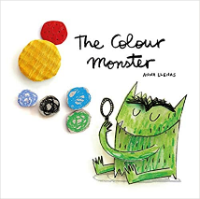
Y1 Whole Class Reading The Colour Monster by Anna Llenas
The Colour Monster wakes up feeling very confused because his emotions
are all over the place; he feels angry, happy, calm, sad and scared all at once!
To help him, a little girl shows him what each feeling means through colour.

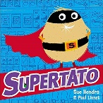
Y1 Whole Class Reading Supertato by Sue Hendra
This is the first book in the bestselling Supertato series – the supermarket hero!

Y1 Whole Class Reading The Bog Baby by Jeanne Willis
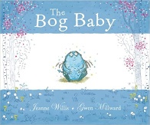
When two sisters go fishing to the magic pond, they find something
much better than a frog or a newt.

Y1 Whole Class Reading Stuck by Oliver Jeffers
Will Floyd ever get his kite back?

Y1 Whole Class Reading Mine by Hiawyn Oram and Mary Rees
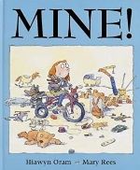
Poor Isabel has a hard time when she visits her friend Claudia, but there is
a lesson learned in sharing at the end.

Y1 Whole Class Reading 15 Things Not to Do with a Puppy by Margaret McAllister
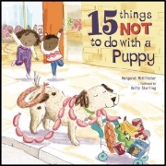
This hilarious, heart-warming picture book is perfect for anyone who has or wants a
new puppy.

Y1 Whole Class Reading Rainforests by Lucy Beckett-Bowman
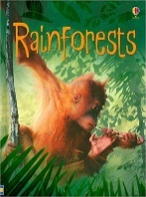
From the tops of the trees to the forest floor, this book is full of some of the weird and
things that live there.

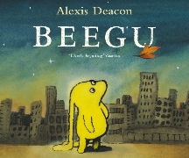
Y1 Whole Class Reading Beegu by Alexis Deacon
Beegu is from another world and manages to get lost on Earth. She wanders off to a
nearby city to find some friends...
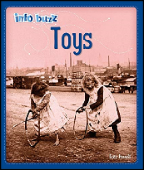
Y1 Whole Class Reading Toys by Izzi Howell
Explore toys that children played with in the past compared to toys today. Discover
the different materials used and how toys have changed.

Y1 Whole Class Reading Eggs and Chicks by Fiona Patchett
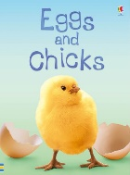
Which bird lays the biggest egg in the world and how do tiny chicks learn to fly?

Y1 Whole Class Reading Number Poems – Zoo Dream by John Foster
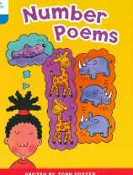
Take a trip to the Zoo with your Year One class using this number poem.

Year 2 Whole Class Reading Units - The Teach Hub

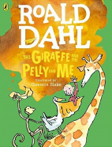
Yr2 Whole Class Reading The Giraffe and the Pelly and me by Roald Dahl
A wonderful story about a boy and his animal friends to introduce your class to
Whole Class Reading.

Yr2 Whole Class Reading Leon and the Place Between by Grahame Baker-Smith
Wanting to prove to his brothers and sister that magic really exists, Leon volunteers
to be in Abdul Kazam's magic show and gets transported to a mysterious world.

Yr2 Whole Class Reading The Great Dragon Rescue by M.P. Robertson
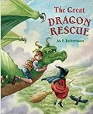
Follow the adventures of how the baby dragon is rescued.

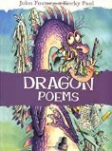
Yr2 Whole Class Reading Dragon Poems
A humorous and a descriptive poem to introduce your class to the delights of poetry.

Yr2 Whole Class Reading Non-Fiction Castles Usborne
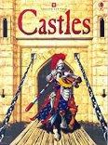
Discover the parts of a castle and what how knights are dressed.

Yr2 Whole Class Reading Non-Fiction Remembrance Day CBeebies
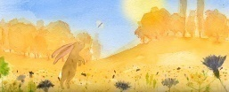
Cover Remembrance Day in Key Stage One in an informative and
thought-provoking way.

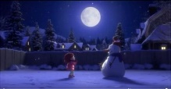
Yr2 Whole Class Reading Lily and the Snowman
A heart-warming story of friendship and commitment using film.

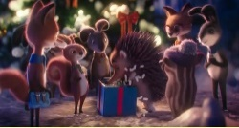
Yr2 Whole Class Reading What would Christmas be without love?
The real message of Christmas using a short film.

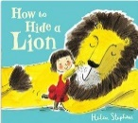
Yr2 Whole Class Reading How to Hide a Lion by Helen Stephens
Follow the friendship of Iris and her friendly lion as they solve problems.

Yr2 Whole Class Reading How to Hide a Lion at School by Helen Stephens
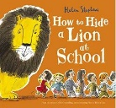
Follow the friendship of Iris and her friendly lion as they solve more problems.

Yr2 Whole Class Reading Mouse Fact File
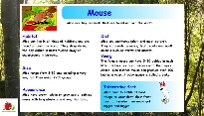
Discover details about mice in this non-chronological report

Yr2 Whole Class Reading Elephants Find and Copy
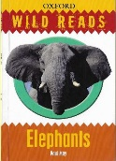
Teach the ‘Find and Copy’ Skills the pupils find difficult within this unit of work

Yr2 Whole Class Reading The Ugly Five by Julia Donaldson
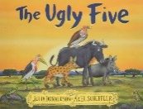
A rhyming, narrative poem with rich vocabulary.

Yr2 Whole Class Reading The Three Little Wolves and the Big Bad Pig weeks 1 & 2
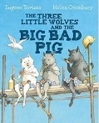
Rediscover alternative versions of Traditional Tales with this humorous text.

Yr2 Whole Class Reading The Three Little Wolves and the Big Bad Pig weeks 3 & 4
Rediscover alternative versions of Traditional Tales with this humorous text.

Yr2 Whole Class Reading Meerkat Mail by Emily Gravett
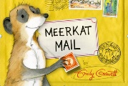
Follow Sunny’s adventures as he explores new places to live.

Yr2 Whole Class Reading The Slightly Annoying Elephant by David Walliams
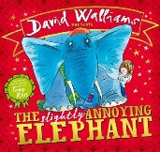
A funny, David Walliams creation about a big, blue, bossy, uninvited elephant!

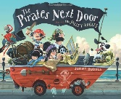
Yr2 - Whole Class Reading Pirates Next Door by Johnny Duddle
Help prepare for SATs with this amazing text about the arrival of pirates in Tilda’s street.

Yr2 Whole Class Reading Prince Cinders – by Babette Cole
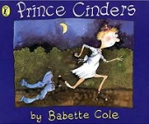
Compare the Traditional Tale of Cinderella to Prince Cinders with the amazing
Babette Cole.

Yr2 Whole Class Reading There is No Dragon in This Story by Lou Carter
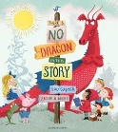
A delightful story of a dragon who wants to be a hero and not a villain for a change.

Yr2 Whole Class Reading Flotsam by David Wiesner
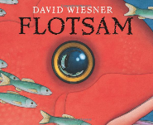
An amazing, wordless, imaginative picture book linked to the treasures of the sea - your
pupils will be amazed...

Yr2 Whole Class Reading Little People, Big Dreams by Amelia Earhart
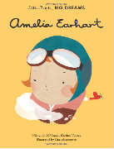
Inspirational women are detailed in these amazing non-fiction texts - just right for the Year 2 curriculum.

Yr2 Whole Class Reading The Last Wolf by Mini Grey
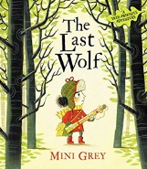
Can Little Red help her new friends in need and recover the wild days of the past?

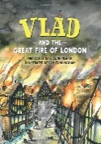
Yr2 Whole Class Reading Vlad and The Great Fire of London by Kate Cunningham
Follow Vlad the flea and Boston the rat as they escape the fire of London.

Yr2 Whole Class Reading Images of God by Marie-Helene Delval
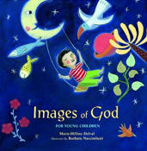
Link poetry and RE with this beautifully illustrated text showing how God can be ‘seen’
everywhere.

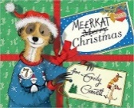
Yr2 Whole Class Reading Meerkat Christmas by Emily Gravett
Follow Sunny’s adventures as he sets off on a journey to find the perfect Christmas.

Yr2 Whole Class Reading On the Way Home by Jill Murphy
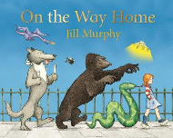
Claire hurts her knee and uses her imagination to explain how it happened as she
goes home.

Yr2 Whole Class Reading The Seeds of Friendship by Michael Foreman
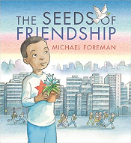
Adam brings the green warmth of his previous home to his new urban world.
An inspiring fable about making friends.

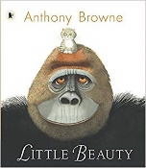
Yr2 Whole Class Reading Little Beauty by Anthony Browne
A very special gorilla is taught a very special skill: sign language. He appears to
have everything he needs, but one day he signs that he is sad and needs a friend.

Yr2 Whole Class Reading The Way Home for Wolf by Rachel Bright
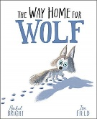
Wolf cub Wilf doesn't want help from anyone but when Wilf finds himself lost and
alone in the chill of the Arctic night, he discovers some special friends.

Yr2 Whole Class Reading Stubby by Michael Foreman
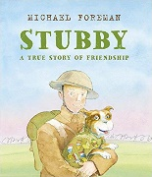
Stubby was a brave soldier, a loyal friend... and a dog. An incredible true story
of Sergeant Stubby, the dog who served bravely in the First World War.

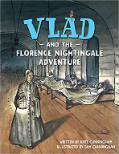
Yr2 Whole Class Reading Vlad and The Florence Nightingale Adventure
by Kate Cunningham
Vlad the flea and Loxton the rat love living in the dirty hospital in Scutari until
Florence Nightingale turns up. Then their lives begin to change.

Yr2 Whole Class Reading Good Little Wolf by Nadia Shireen
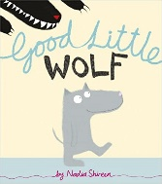
Rolf is such a good little wolf, but he has to prove he can still be a real wolf
when he is challenged to be bad by a big bad wolf.

Yr2 Whole Class Reading Sully the Seahorse by Natalie Pritchard
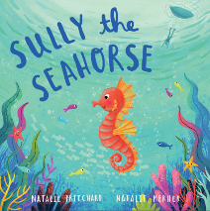
Sully the Seahorse, is a gorgeous tale about a seahorse who longs to be fast like
the whales and isn’t happy being who he is. But he takes a journey of self-discovery
where he finds that all of us are special in our own unique way.

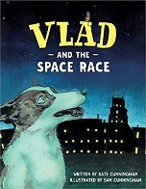
Yr2 Whole Class Reading Vlad and the Space Race by Kate Cunningham
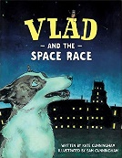
Strelka and Vlad are living on the streets in Moscow before being taken on an adventure
of a lifetime. A true story about some of the first animals in space.

Yr2 Whole Class Reading Here We Are by Oliver Jeffers
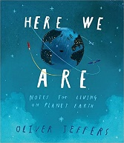
Discover the delights of the planet Earth with this thought-provoking picture book.
A non-narrative unit.

KS1 Whole Class Reading The Fairy Who Sings by Cheryl Davies
A beautifully illustrated rhyming story, which encompasses the magic of fairies
with important key messages of self-esteem, friendship, kindness and courage.

KS1 Whole Class Reading OG by Joanne Hutchinson
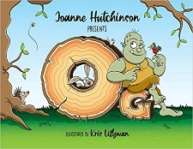
Children love identifying the stories set throughout the book, and listening to how
OG becomes a hero in the most unexpected way.

Y2 Supertato (Books are Rubbish) by Sue Hendra
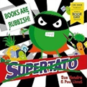
The Evil Pea thinks books are rubbish! Find out whether the veggies can prove
him wrong in this mini picture book created especially for World Book Day 2020.

Y2 Whole Class Reading The Bog Baby by Jeanne Willis
When two sisters go fishing to the magic pond, they find something
much better than a frog or a newt.

Y2 Whole Class Reading Avocado Baby by John Burningham
The Hargraves want their new baby to grow up big and strong. One day, Mrs Hargraves
finds an avocado in the fruit bowl and the baby gobbles it up. Soon, the strangest things
start to happen…

Y2 Whole Class Reading The Polar Express by Chris Van Allsburg
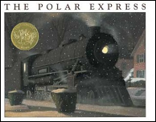
Late on Christmas Eve, a boy boards a mysterious train bound for the
North Pole.

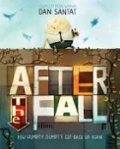
Y2 Whole Class Reading After the Fall by Dan Santat
After the Fall follows Humpty's journey after he got back up again...

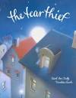
Y2 Whole Class Reading The Tear Thief by Carol Ann Duffy
Every night the Tear Thief steals the tears of crying children. But what does she do
with all those tears?

Y2 Whole Class Reading The Twits by Roald Dahl
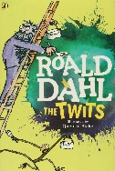
A married pair of horrible twits who like to play tricks on each other.

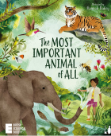
Y2 Whole Class Reading The Most Important Animal of All by Penny Worms
An award-winning picture book about seven animals - beautifully illustrated by
Hannah Bailey and endorsed by The British Ecological Society.

Y2 Whole Class Reading The Deadliest Animals to Humans
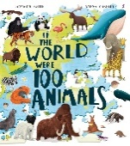
A thought-provoking book for children, exploring biodiversity and opening up
discussions about the environment.

Y2 Whole Class Reading Inside the Villains by

Y2 Whole Class Reading The Lighthouse Keeper’s Lunch

Year 3 Whole Class Reading Units - The Teach Hub

Yr3 Whole Class Reading Leon and the Place Between by Grahame Baker-Smith
Wanting to prove to his brothers and sister that magic really exists, Leon volunteers
to be in Abdul Kazam's magic show and gets transported to a mysterious world.

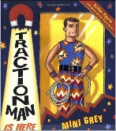
Yr3 Whole Class Reading Traction Man by Mini Grey weeks 1 and 2
Follow Traction man and his pet scrubbing brush on their adventures around
the house in this comic style picture book.

Yr3 Whole Class Reading Traction Man by Mini Grey weeks 3 and 4
Follow Traction man and his pet scrubbing brush on their adventures around
the house in this comic style picture book.

Yr3 Whole Class Reading The Iron Man by Ted Hughes weeks 1 and 2
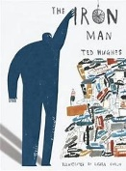
Read this classic text to your Year Three pupils - an Iron Man befriending a small
boy and defending the world from a dragon from outer space.

Yr3 Whole Class Reading The Iron Man by Ted Hughes weeks 3 and 4
Read this classic text to your Year Three pupils - an Iron Man befriending a small
Boy and defending the world from a dragon from outer space.

Yr3 Whole Class Reading The Rainforest Grew All Around - Non-Fiction
by Susan K Mitchell
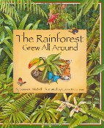
The jungle comes alive as children learn all about the rainforest in this beautiful
book.

Yr3 Whole Class Reading The Diary of a Killer Cat by Anne Fine
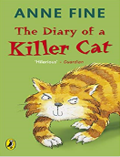
Tuffy is no ordinary cat – he is a killer cat! Humour and a cat’s view of the world
makes this story a firm favourite.

Yr3 Whole Class Reading Fantastic Mr. Fox by Roald Dahl
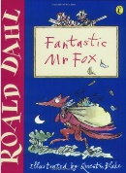
The farmers have hatched a plan to shoot Mr. Fox dead, but just when they
think Mr. Fox can't possibly escape, he makes a FANTASTIC plan of his own.

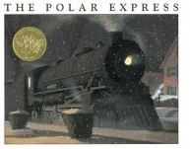
Yr3 Whole Class Reading The Polar Express by Chris Van Allsburg
Late on Christmas Eve, a boy boards a mysterious train bound for the North Pole.

Yr3 Whole Class Reading The First Drawing by Mordicai Gerstein
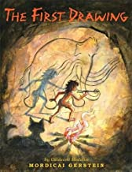
A story set in the Stone Age that looks at how the first drawing could have
been made in a cave.

Yr3 Whole Class Reading The Woolly Mammoth
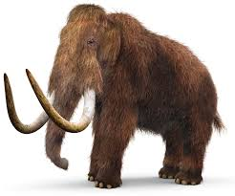
A non-chronological report based on the Woolly Mammoth and its comparison
to the elephant. A great resource for a Stone Age topic!

Yr3 Whole Class Reading A Swan Warrior (The Dragon’s Hoard) by Lori Don
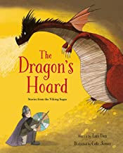
This amazing story about a Viking battle is one of a selection of eleven sagas
in this text, where the tales are brought to life with vivid illustrations and details.

Y3 Whole Class Reading Romans on the Rampage by Jeremy Strong
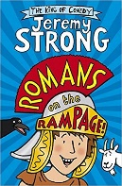
Perilus is a Roman boy who is crazy about chariot racing. He loves to practise
in his own homemade chariot and dreams of riding in the Circus Maximus himself
one day.

Y3 Whole Class Reading Roman Diary by Richard Platt
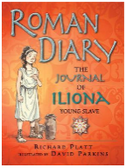
The story of Iliona, an educated Greek girl, who has been orphaned and sold
as a slave in Rome.

Y3 Whole Class Reading Matchbox Diary by Paul Fleischman
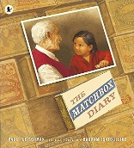
The story of a little girl visiting her great-grandfather. They explore his collection
of matchboxes making up his diary when he was a boy, containing objects she
can hold in her hand, each one evoking a memory.

LKS2 Whole Class Reading Here We Are by Oliver Jeffers
Discover the delights of the planet Earth with this thought-provoking picture book.
A non-narrative unit.

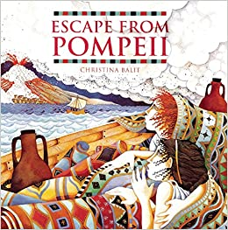
LKS2 Whole Class Reading Escape from Pompeii by Christina Balit
Travel back in time to experience the impact of the eruption of Mount
Vesuvius in the Roman Empire.

Y3 Whole Class Reading Little Leaders – Bold Women in Black History
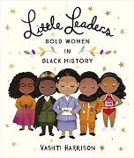
This book showcases women who changed the world.

LKS2 Whole Class Reading The Wild Robot by Peter Brown
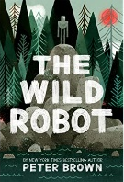
When robot Roz opens her eyes for the first time, she discovers that she
is alone on a remote, wild island.

LKS2 Whole Class Reading Oliver and the Seawigs
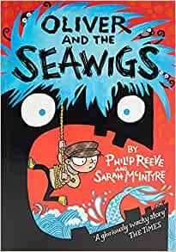
Along with his new friends, a grumpy old albatross, a short-sighted mermaid,
and a friendly island called Cliff, Oliver goes off in search of his missing parents.

Y3 Whole Class Reading Voices in the Park Weeks 1 and 2 by Anthony Browne
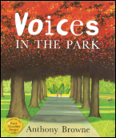
Four different voices tell their own versions of the same walk in the park.

Y3 Whole Class Reading Voices in the Park Weeks 3 and 4 by Anthony Browne
Four different voices tell their own versions of the same walk in the park.

Y3 Whole Class Reading The Tin Forest by Helen Ward and Wayne Anderson
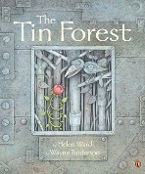
A beautifully illustrated book about a windswept place, close to forgotten, that was
filled with all the things that no one wanted.

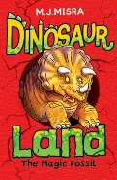
Y3 Whole Class Reading Dinosaur Land: The Magic Fossil by M J Misra
Max is dinosaur mad, so when an ancient fossil whisks him away to an incredible
land full of dinosaurs, he can’t believe his luck.

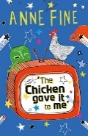
LKS2 Whole Class Reading The Chicken gave it to me by Anne Fine
An epic tale of cruelty and bravery, the story of a chicken who flies frillions of miles...

LKS2 Whole Class Reading Quentin the Squirrel by David Anderson (Pep the Poet)
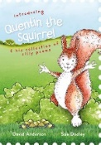
Inside this book you will discover a selection of funny, cheeky and hilarious poems that
are great to be read alone or a delight to share with others.

Y3 Whole Class Reading Leaf by Sandra Dieckmann
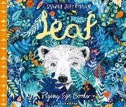
A beautifully illustrated picture book about a polar bear arriving unexpectedly
in the woods.

LKS2 Whole Class Reading Open Wide by Dr Letizia Diamante & Ed J. Brown
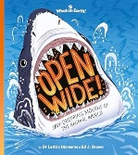
Explore the marvellous mouths of the animal kingdom, from the awesome
jaws of the great white shark to the tiny teeth of the garden snail.

Year 4 Whole Class Reading Units - The Teach Hub

Yr4 Whole Class Reading Leon and the Place Between by Grahame Baker-Smith
Wanting to prove to his brothers and sister that magic really exists, Leon volunteers
to be in Abdul Kazam's magic show and gets transported to a mysterious world.

Yr4 Whole Class Reading A Stone for Sacha by Aaron Becker weeks 1 and 2
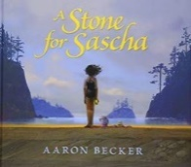
A beautiful, wordless picture book focusing on the endless cycle of life and how
nothing is ever lost or forgotten.

Yr4 Whole Class Reading A Stone for Sacha by Aaron Becker weeks 3 and 4
A beautiful, wordless picture book focusing on the endless cycle of life and how
nothing is ever lost or forgotten.

Yr4 Whole Class Reading Anglo-Saxon Boy Weeks 1 and 2 by Tony Bradman
(same as Yr5 unit)
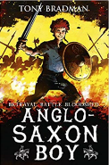
The story of one Anglo-Saxon boy's journey to the Battle of Hastings in 1066: Key Stage 2 History brought to life as battle-packed adventure.

Yr 4 Whole Class Reading Anglo-Saxon Boy Weeks 3 and 4 by Tony Bradman
(same as Yr5 unit)
The continuing story of one Anglo-Saxon boy's journey to the Battle of Hastings in
1066: Key Stage 2 History brought to life as battle-packed adventure.

Yr4 Whole Class Reading The Polar Express by Chris Van Allsburg
Late on Christmas Eve, a boy boards a mysterious train bound for the North Pole.

Yr4 Whole Class Reading The First Drawing by Mordicai Gerstein
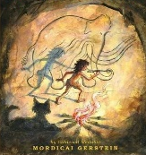
A story set in the Stone Age that looks at how the first drawing could have been
made in a cave.

Yr4 Whole Class Reading The Woolly Mammoth
A non-chronological report based on the Woolly Mammoth and its comparison
to the elephant. A great resource for a Stone Age topic!

Yr4 Whole Class Reading A Swan Warrior (The Dragon’s Hoard) by Lori Don
This amazing story about a Viking battle is one of a selection of eleven sagas
in this text, where the tales are brought to life with vivid illustrations and details.

Y4 Whole Class Reading River Poetry by Valerie Bloom and David Windle
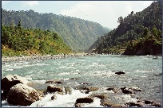
Two distinctive, detailed poems to inspire imagery of rivers in the listener’s mind.

Y4 Whole Class Reading Vikings in 30 Seconds by Philip Steele
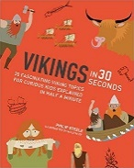
Children will discover all about these amazing warriors, including seafaring, raiding
and how they traded with other lands.

Y4 Whole Class Reading The Great Kapok Tree by Lynne Cherry
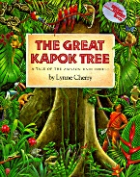
One day, a man exhausts himself trying to chop down a giant kapok tree. The
dependence on others for living is explored in this text.

LKS2 Whole Class Reading Here We Are by Oliver Jeffers
Discover the delights of the planet Earth with this thought-provoking picture book.
A non-narrative unit.

Yr 4 Whole Class Reading King Arthur by Marcia Williams
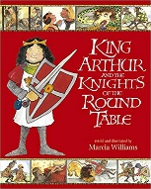
A comic-strip re-telling of some of Britain's best-loved Arthurian stories
and legends.

Yr 4 Whole Class Reading How to Train your Dragon by Cressida Cowell
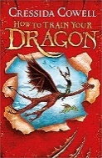
This is an award-winning story of Vikings and dragons which inspired the
How to Train Your Dragon films.

LKS2 Whole Class Reading Escape from Pompeii by Christina Balit
Travel back in time to experience the impact of the eruption of Mount
Vesuvius in the Roman Empire.

LKS2 Whole Class Reading The Wild Robot by Peter Brown
When robot Roz opens her eyes for the first time, she discovers that she
is alone on a remote, wild island.

LKS2 Whole Class Reading The Firework Maker’s Daughter by Philip Pulman
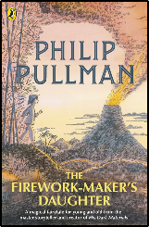
Lila knows that she wants to follow in her father’s footsteps, so she heads
off alone on a journey – a journey filled with dangers to find out the secrets
of being a Firework Maker.

LKS2 Whole Class Reading Oliver and the Seawigs
Along with his new friends, a grumpy old albatross, a short-sighted mermaid,
and a friendly island called Cliff, Oliver goes off in search of his missing parents.

Y4 Whole Class Reading Pompeii
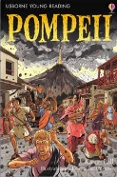
A narrative style retelling of the major historical catastrophe.

Y4 Whole Class Reading Varak Paw by SF Said
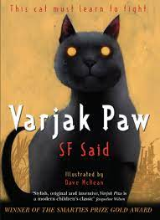
Varjak Paw is a Mesopotamian Blue kitten who lives high up in an old house
on a hill. He's never left home, but then his grandfather tells him about the
Way - a secret martial art for cats.

Y4 Whole Class Reading The Butterfly Lion by Michael Morpurgo
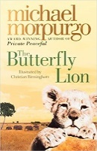
Bertie rescues an orphaned white lion cub from the African veld. They are
inseparable until Bertie is sent away to a boarding school and the lion is sold
to a circus.

Y4 Whole Class Reading The Lion and the Unicorn by Shirley Hughes
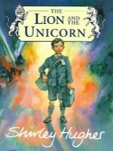
When Lenny’s father goes to fight in the Second World War, he gives his son a
brass badge with two animals engraved on it: a lion for bravery and a unicorn for
courage.

Y4 Whole Class Reading Charlotte’s Web by E. B. White
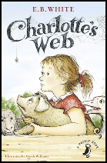
The story of a little girl named Fern, who loves a little pig named Wilbur
- and of Wilbur's dear friend, Charlotte, a beautiful large grey spider.

LKS2 Whole Class Reading Quentin the Squirrel by David Anderson (Pep the Poet)
Inside this book you will discover a selection of funny, cheeky and hilarious poems that
are great to be read alone or a delight to share with others.

Y4 Whole Class Reading The Funky Peacock by David Anderson (Pep the Poet)
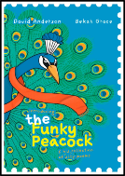
It's time to buckle up, hold on to your hat and fly into the vivid imagination of
Pep the Poet.

LKS2 Whole Class Reading Open Wide by Dr Letizia Diamante & Ed J. Brown
Explore the marvellous mouths of the animal kingdom, from the awesome
jaws of the great white shark to the tiny teeth of the garden snail.

Year 5 Whole Class Reading Units - The Teach Hub

Yr5 Whole Class Reading Leon and the Place Between by Grahame Baker-Smith
Wanting to prove to his brothers and sister that magic really exists, Leon volunteers
to be in Abdul Kazam's magic show and gets transported to a mysterious world.

Yr5 Whole Class Reading Anglo-Saxon Boy Weeks 1 and 2 by Tony Bradman
(same as Yr4 unit)
The story of one Anglo-Saxon boy's journey to the Battle of Hastings in 1066: Key Stage 2 History brought to life as battle-packed adventure.

Yr5 Whole Class Reading Anglo-Saxon Boy Weeks 3 and 4 by Tony Bradman
(same as Yr4 unit)
The continuing story of one Anglo-Saxon boy's journey to the Battle of Hastings in
1066: Key Stage 2 History brought to life as battle-packed adventure.

Yr5 Whole Class Reading Cogheart (prologue) by Peter Bunzl
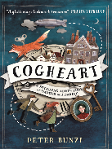
Lily's life is in mortal peril. Her father is missing, and now silver-eyed men stalk
her through the shadows. What could they want from her?

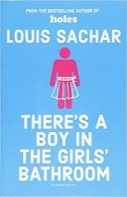
Yr 5 Whole Class Reading There's a Boy in the Girls' Bathroom by Louis Sachar
Bradley Chalkers IS the oldest kid in the fifth grade. He tells enormous lies
and he picks fights with girls. No one likes him. This is a story about
believing in yourself...

Yr 5 Whole Class Reading Who Let the Gods out? by Maz Evans
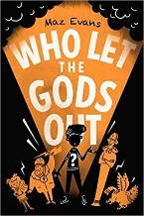
Elliot's mum is poorly, and he is in trouble at school, but a shooting star crashes
to earth and changes his life forever.

Yr 5 Whole Class Reading Beowulf by Michael Morpurgo Weeks 1 and 2
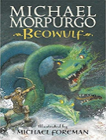
In fifth-century Denmark, a murderous monster stalks the night, and only Beowulf has
the strength and courage to defeat him. This is the story of Beowulf's terrifying quest
to destroy the terrifying Grendel. The first unit of this set.

Yr 5 Whole Class Reading Beowulf by Michael Morpurgo Weeks 3 and 4
In fifth-century Denmark, a murderous monster stalks the night, and only Beowulf has
the strength and courage to defeat him. This is the story of Beowulf's terrifying quest
to destroy the terrifying Grendel. The second unit of this set.

UKS2 Whole Class Reading Kensuke’s Kingdom by Michael Morpurgo
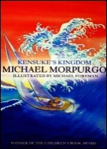
Michael's parents buy a yacht and take him off to sail around the world. But a tragedy
occurs and Michael is shipwrecked with no food or no water and he is all alone - or so
he thinks...

Yr 5 Whole Class Reading Gregor the Overlander by Suzanne Collins
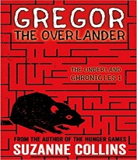
The first in a series from the author of THE HUNGER GAMES. When eleven-year-old
Gregor falls through a grate in the laundry room of his apartment building, he hurtles
into the dark Underland.

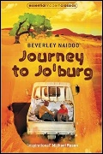
UKS2 Whole Class Reading Journey to Jo’burg by Beverley Naidoo (5 week unit)
The background of the story is South Africa during the apartheid years. Two young
children are travelling alone to Jo’burg to try to find their mother who is needed back
in the family village.

UKS2 Whole Class Reading Here We Are by Oliver Jeffers
Discover the delights of the planet Earth with this thought-provoking picture book.
A non-narrative unit.

Y5 Whole Class Reading Little Leaders – Bold Women in Black History
This book showcases women who changed the world.

Y5 Whole Class Reading Rooftoppers - – Katherine Rundell
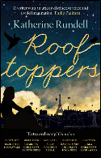
A beautiful story about pursuing your dreams and never ignoring a ‘possible’.

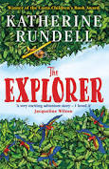
UKS2 Whole Class Reading The Explorer – Katherine Rundell
A story full of friendship, adventure and survival in the Amazon Rainforest

UKS2 Whole Class Reading A Monster Calls – Patrick Ness
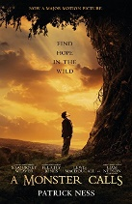
Set in present-day England, it features a boy who struggles to cope with
the consequences of his mother's illness.

UKS2 Whole Class Reading The Story Shop Nikki Gamble
St George and the Dragon and How Fire Came to Earth
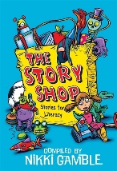
Based on two texts from this collection: a myth and a legend.

UKS2 Whole Class Reading My Heart is a Poem

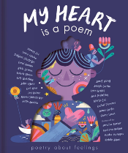
Based on two poems by Karl Nova and Jay Hulmes.

UKS2 Whole Class Reading Ella on the Outside by Cath Howe

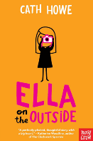
This book focuses on changes and challenges in new and different situations.

UKS2 Whole Class Reading A Different Kind of Freedom by Richard O’Neill

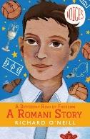
This book focuses on tradition and ways of life.

UKS2 Whole Class Reading The Fossil Hunter by Kate Winter

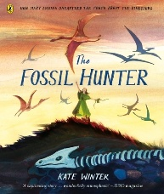
Unearth the mysteries of ancient fossils and discover the life and legacy
of Mary Anning.

UKS2 Whole Class Reading Ella on the Outside by Cath Howe

This book focuses on changes and challenges in new and different situations.

UKS2 Whole Class Reading My Heart is a Poem

Based on two poems by Karl Nova and Jay Hulmes.

Y5 Whole Class Reading A Different Kind of Freedom by Richard O’Neill

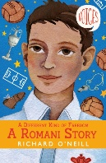
This book focuses on tradition and ways of life.

UKS2 Whole Class Reading The Fossil Hunter by Kate Winter

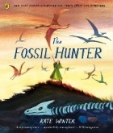
Unearth the mysteries of ancient fossils and discover the life and legacy
of Mary Anning.

Year 6 Whole Class Reading Units - The Teach Hub

Yr6 Whole Class Reading Leon and the Place Between by Grahame Baker-Smith
Wanting to prove to his brothers and sister that magic really exists, Leon volunteers
to be in Abdul Kazam's magic show and gets transported to a mysterious world.

Yr6 Whole Class Reading Pig Heart Boy by Malorie Blackman
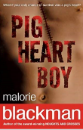
A thought-provoking journey of a thirteen-year old boy wanting a normal life - but he
needs a heart transplant.

Yr6 Whole Class Reading Holes by Louis Sachar
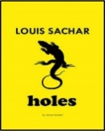
A story of friendship with clever plot twists using vivid descriptions throughout.

Yr6 Whole Class Reading Letters from the Lighthouse by Emma Carroll
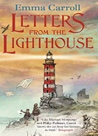
Olive must solve a mystery of her own within a World War Two setting of
mysterious dangers and secret codes.

Yr6 Whole Class Reading Trash by Andy Mulligan
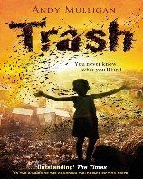
Raphael lives on a dumpsite, making a living sifting through rubbish.
One day, he makes an extraordinary and deadly discovery.

Yr6 Whole Class Reading Once by Morris Gleitzman
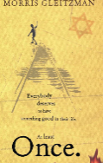
The story of a young Jewish boy who is determined to escape the orphanage he
lives in to save his Jewish parents from the Nazis.

Yr6 Whole Class Reading Journey to the River Sea by Eva Ibbotson
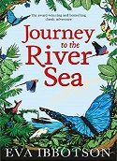
Maia, an orphan, can’t wait to reach her distant relatives a thousand miles
up the Amazon.

UKS2 Whole Class Reading Kensuke’s Kingdom by Michael Morpurgo
Michael's parents buy a yacht and take him off to sail around the world. But a tragedy
occurs and Michael is shipwrecked with no food or no water and he is all alone - or so
he thinks...

Yr 6 Whole Class Reading The Water Tower by Gary Crew
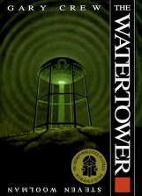
An unusual but intriguing picture book for Key Stage Two. This book contributes
as much through its pictures as it does its text and has plenty of mystery to discover.
Sinister with a twist...

Yr 6 Whole Class Reading Gregor the Overlander by Suzanne Collins
The first in a series from the author of THE HUNGER GAMES. When eleven-year-old
Gregor falls through a grate in the laundry room of his apartment building, he hurtles
into the dark Underland.

Yr 6 Whole Class Reading The Boy at the Back of the Class by Onjali A.Rauf
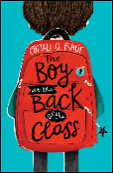
An inspiring tale focusing on a child refugee that will help children think about
what it is to be a good person whatever your circumstances.

Yr 6 Whole Class Reading The Girl of Ink and Stars by Kiran Millwood Hargrave
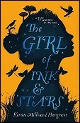
Forbidden to leave her island, Isabella dreams of the faraway lands her cartographer
father once mapped.

UKS2 Whole Class Reading Journey to Jo’burg by Beverley Naidoo (5 week unit)
The story is set in South Africa during the apartheid years. Two young
children are travelling alone to Jo’burg to try to find their mother who is needed back
in the family village.

Yr 6 Whole Class Reading The 1,000-Year-Old Boy by Ross Welford
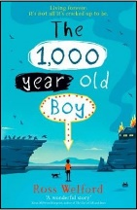
This is a story about someone who wants to stop living forever...Alfie Monk is
like any other nearly teenage boy - except he's 1,000 years old and can
remember the last Viking invasion of England.

UKS2 Whole Class Reading Here We Are by Oliver Jeffers
Discover the delights of the planet Earth with this thought-provoking picture book.
A non-narrative unit.

UKS2 Whole Class Reading The One and Only Ivan
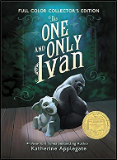
A poignant story about a gorilla kept in captivity and the determination to change
things for the better - a story of friendship, art, and hope.

Y6 Whole Class Reading Brightstorm

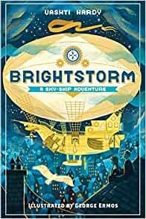
Twelve-year-old twins Maudie and Arthur’s world comes crashing in when
their explorer dad is reported dead in his mission to get to South Polaris.

UKS2 Whole Class Reading The Explorer – Katherine Rundell
A story full of friendship, adventure and survival in the Amazon Rainforest

UKS2 Whole Class Reading A Monster Calls – Patrick Ness
Set in present-day England, it features a boy who struggles to cope with
the consequences of his mother's illness.

UKS2 Whole Class Reading The Story Shop Nikki Gamble
St George and the Dragon and How Fire Came to Earth
Based on two texts from this collection: a myth and a legend.

